Data Analysis Report[World Happiness Report]

OBJECTIVE:
This project aims to analyze the World Happiness Report dataset to compare well-being matrices globally, identify what factors correlates with happiness and if happiness changed over the time or not.
DATA CLEANING:
In this step, we examined the dataset to identify and resolve any issues such as missing or NaN values, inappropriate data types, and unnecessary columns. The process involved the following:
- Datatype validation:
We began with checking the datatypes of all the columns using ‘df.dtypes’, if any column found incorrect then we will resolve change the datatype of that particular column but here all the columns were of correct datatype.

- Checking missing values:
We then verified whether all columns had appropriate data types using df.dtypes. We found that there are no null values and all the values are appropriate.

- Dropping irrelevant columns:
Here comes last step of data cleaning, in this step we remove the irrelevant or columns which are not needed, After going through every column we found that in our dataset, the feature “Overall rank” is not needed as per the insights needed.

Code block:
>>> df.drop(columns=['Overall rank'],inplace=True)

EDA[EXPLORATORY DATA ANALYSIS]:
In this step, we took a deeper look of a data, digging bit more using commands like df.head(), df.tail(), df.shape, df.describe and groupby. Here is how we did this step:
- Firstly we started with taking a overall look of the data using commads:
>>df.head(): to print first 6 values.
>>df.tail(): to print last 6 values.
>>df.shape: to print the shape of the dataset.
>>df.describe(include=’object’)
>>df.info()

- Then we began digging bit deeper into it leveraging visualization liberaries like matplotlib and seaborn, we decided to extract our answers using visualization because of the type of data, as we know this data is more about trends rather than extracting some sort of numerical value or something, that’s why seeing this data from plot’s point of view is an excellent decision.
We first started with finding the correlations between the features:
- ‘Social support’ and ‘Freedom to make life choices’:
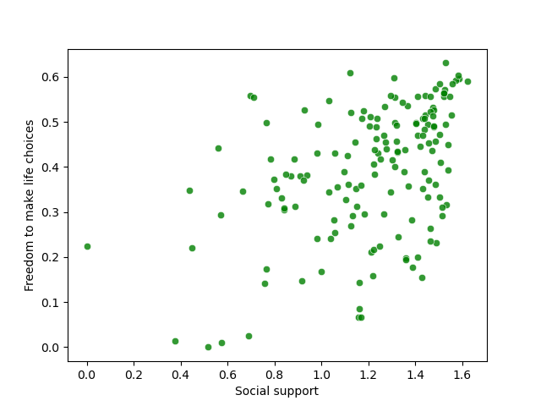
Code block:
>>>sns.scatterplot(data=df,x='Social support',y='Freedom to make life choices',alpha=0.8,color='green')
This is a simple scatter plot of ‘Social support’ and ‘Freedom to make life choices’, By which we can easily conclude that social support' is directly proportional to 'Freedom to make life choices'.

- ‘Generosity’ and ‘Socail support‘:
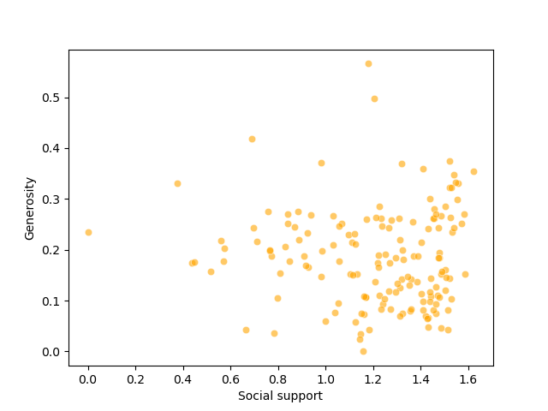
Code block:
>>>sns.scatterplot(data=df,x='Social support',y='Generosity',alpha=0.6,color='orange')
This is a simple scatter plot of ‘Generosity’ and ‘Socail support‘, through which we figured out that ocial support is more then generosity is more.

- Since our goal was to compare global well-being metrics, we identified ‘Social Support’, ‘Freedom to Make Life Choices’, and ‘Generosity’ as key indicators for analysis. To examine the relationships between these features, we decided to use a heatmap to visualize their correlations. This approach was chosen because it allows us to simultaneously assess correlation and compare multiple features in a clear and intuitive way. Using a scatter plot here would not have been ideal, as it is comparatively complex to interpret and less efficient for this purpose..
Code block :
>>>sns.heatmap(df[['Social support','Freedom to make life choices','Generosity']].corr())
>>>plt.title('Comparing well being matrices')
>>>plt.savefig('happiness3.png')
Explaination:

This will generates a heatmap to visualize the correlation between the features ‘Social support’, ‘Freedom to make life choices’, and ‘Generosity’. The sns.heatmap() function computes pairwise correlations and displays them as a color-coded matrix. A title is added for context, and the plot is saved as ‘happiness3.png’.
Ana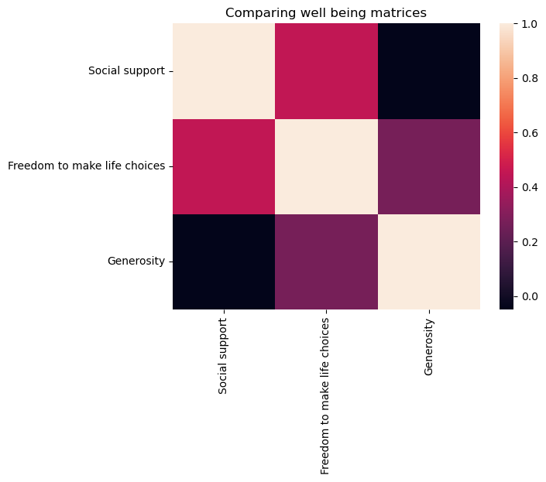

Analysis:
From the heatmap, it is evident that ‘Freedom to Make Life Choices’ shows a stronger correlation with ‘Social Support’ compared to ‘Generosity.’ On the other hand, ‘Social Support’ and ‘Generosity’ appear to have little to no correlation with each other.
Since our analysis focuses on happiness, it becomes essential to identify which factors are most closely correlated with the Happiness Score. A heatmap serves as an effective tool to visualize and present these relationships clearly.

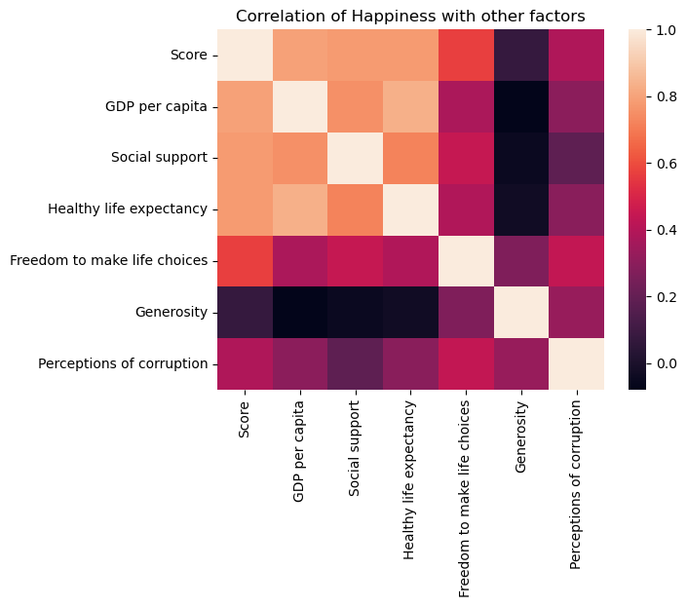

Code bock:
sns.heatmap(df[['Score','GDP per capita','Social support','Healthy life expectancy','Freedom to make life choices','Generosity','Perceptions of corruption']].corr())
plt.title('Correlation of Happiness with other factors')
plt.savefig('happiness4.png',bbox_inches = 'tight')
Explaination:
sns.heatmap(...): Generates a heatmap to visualize the correlation between ‘Score’ (Happiness) and other factors like GDP per capita, Social support, Healthy life expectancy, etc.
plt.title('Correlation of Happiness with other factors'):Adds a title to the heatmap for context.
plt.savefig('happiness4.png', bbox_inches='tight'): Saves the heatmap as an image named happiness4.png, with bbox_inches='tight' to ensure the layout fits neatly.

Insight we got:
The factors which correlates with happiness are 'GDP peer capita', 'Social support' and 'Healthy life expectency'.

Finding the trend of happiness over the years:

We can not find this trend directly from this one dataset as here is not any column of period or time or year, so we have to take the help of many datasets, so my approach is to import all the available datasets checking whether all the dataset have the score feature named ‘happiness score’, here, 2017,2018 and 2019 dataset was not same so we renamed it.
Code block:
>>>df_2017.rename(columns={'Score': 'Happiness Score'}, inplace=True)
>>>df_2018.rename(columns={'Score': 'Happiness Score'}, inplace=True)
>>>df_2019.rename(columns={'Score': 'Happiness Score'}, inplace=True)

Then we merged all the datasets with concat() funciton and stored the merged dataset in a new dataset.
Code block:
>>>df_merged=pd.concat([df_2015,df_2016,df_2017,df_2018,df_2019],ignore_index=True)

Then I checked for null or NaN values in happiness score dataset using isnull() funtion
>>>contains_nan = df_merged['Happiness Score'].isnull().any()
>>>print(contains_nan)
Since there are NaN values in the 'Happiness Score' column, so first we will resolve this despirency by removing the nan values and to do so we have function called dropna().
>>>df_merged=df_merged.dropna(subset='Happiness Score')
>>>df_merged.dtypes

Now, finally we have a dataset with which we can directly plot a lineplot showing the trend of ‘Change in happiness over the time’

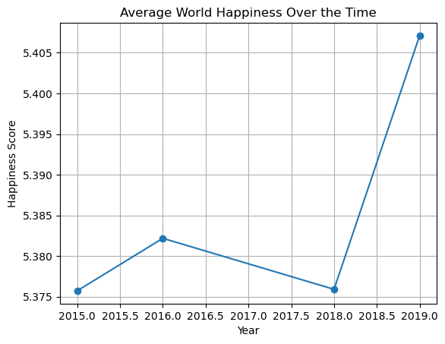
Code Block:

To analyze how global happiness has changed over time, we first calculated the average happiness score per year using the following approach:

>>>avg_happiness_per_year = df_merged.groupby('Year')['Happiness Score'].mean().reset_index()
This line groups the merged dataset by ‘Year’ and computes the mean happiness score for each year, resulting in a simplified dataframe suitable for trend analysis.
Next, a line plot was created to visualize the yearly trend in global happiness:

>>>plt.plot(avg_happiness_per_year['Year'], avg_happiness_per_year['Happiness Score'], marker='o')
The plot displays the average happiness score over the years with circular markers to emphasize each data point.
We added a descriptive title and axis labels to clearly convey the purpose of the visualization:

>>>plt.title('Average World Happiness Over the Time')
>>>plt.xlabel('Year')
>>>plt.ylabel('Happiness Score')
Gridlines were included to enhance readability, and the final plot was displayed using:

>>>plt.grid(True)
>>>plt.show()
This visualization helps us observe fluctuations and long-term trends in global happiness, providing insight into how well-being has evolved year by year.

Analysis:
Here, we can see the score was lowest in 2015 then increased in 2016 then again went down in 2018 but after 2018 it exponentially increased and gone highest as never before in 2019.

Final Analysis:
- From the heatmap it is clear that 'Freedom to make life choices' is less correlated to 'Generosity' rather it is more correlated with 'Socail support'. Meanwhile 'Social support' and 'Generosity' is not at all correlated to each other.
- From the heatmap we can see, the factors which correlates with happiness are 'GDP peer capita', 'Social support' and 'Healthy life expectency'.
- The happiness score was lowest in 2015 then increased in 2016 then again went down in 2018 but after 2018 it exponentially increased and gone highest as never before in 2019.

Questions Asked:
- What factors correlate with happiness?
Ans) The factors which correlates with happiness are 'GDP peer capita', 'Social support' and 'Healthy life expectency'.
- Has happiness changed over time?
- Ans) Yes, the happiness score was lowest in 2015 then increased in 2016 then again went down in 2018 but after 2018 it exponentially increased and gone highest as never before in 2019.

